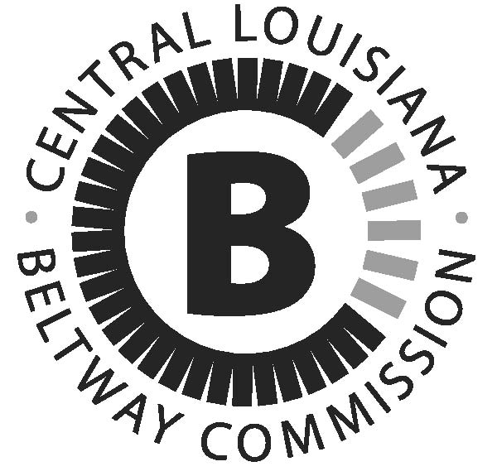

**Board of Directors**

**Chairman**

Mayor Jacques Roy, Alexandria

Mayor Jonathan Dean, Ball

Mayor Clarence Fields, Pineville

Mayor David Butler, Woodworth

Bryan Bossier, Boyce

Harry Silver, Alexandria

Joseph Bishop, Rapides Parish

Reldon Owens, Cenla CoC

Arnold Murrell, Grant Parish

Charles Jones, Avoyelles Parish

Jon Grafton, England Authority

Murphy LeDoux, LaDOTD

Dr. Paul Coreil, LSU-A

Dr. Joe Aguillard, Louisiana College

**M E M O R A N D U M**

DATE: September 16th, 2013

TO: Central Louisiana Infrastructure Beltway Commission Board Members

FROM: Vera Zhang, Rapides Area Planning Commission

RE: BELTWAY COMMISSION MEETING - October 2nd, 1:30pm

The Central Louisiana Regional Infrastructure Beltway Commission will be meeting on **Wednesday, October 2nd at 1:30 pm** in the **Rapides Area Planning Commission Conference Room, 1405 Frank Andrews Blvd, Alexandria**.

At this point, there is no alternate for Beltway Commission board members. Please appoint an alternate for yourself, and we will discuss and possibly approve all the alternates at the upcoming meeting. We will also review the Beltway Commission Bylaws to make sure we have all the officers elected or appointed.

Please make every effort to attend.

If you have questions feel free to call me at 318.487.5401 ext. 29.

# Central Louisiana REgional Infrastructure

# BeltWAY Commission

1405 Frank Andrews Blvd

Alexandria, LA 71303

Phone (318) 487-5401 ext: 29

Fax (318) 487-5406

Web site http://www.rapc.info